Sources and Info and Images: Generally the material that will go into the proposal.

R. Daghrir, P. Drogui. Tetracycline antibiotics in the environment: a review. 2013. DOI 10.1007/s10311-013-0404-8

-main use in vets humans and ag puposes

- not degraded highly excreted (70%) varying (30-90)

- highly hydrophilic + low volatility

-inihints growth of some terrestrial species

= wwtps do nothing as of right now

* Oxidizble by normal processes
* Low level long term has effect withencdocrine disruption, chromnic toxicity, anib restisnt
* Borad spec antib g+ and g- and some parasites
* 3 kinds chlortetracy cline, oxytetracycline, tetracycline (Table 1 has info
* Low henry’s contsntat (3.45E-24 to 3.91E-26)🡪 low loss from volatilizartion
* High solubulity .008-.063 mol/L
* -stable in acids
* Have been detected in surface water, ground water, wastewater, municipal sewage soil and sediments,
* Remoal in WWTP range from 12-90%
* Bacteriostatic: taken up by cells, reversible binding with 30S subunit of ribosome, prevent binding of aminoacyl transfer to DNA thus no protein synthesis thus no cell growth

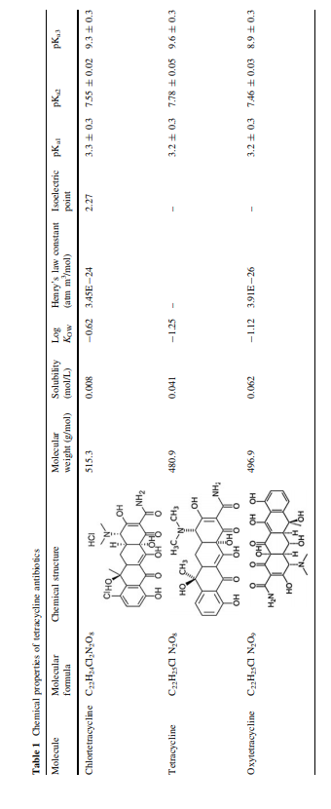

World wide uses:

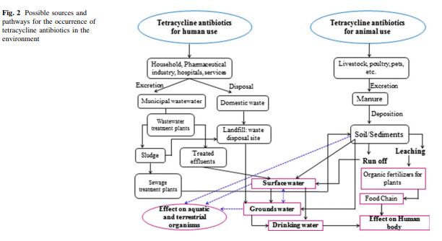 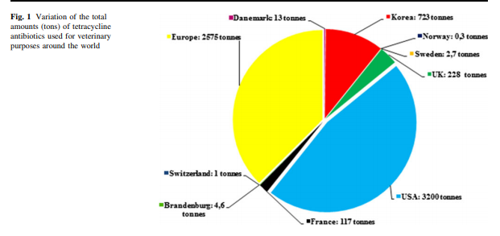

-Potential to increase bacterial resitacnce

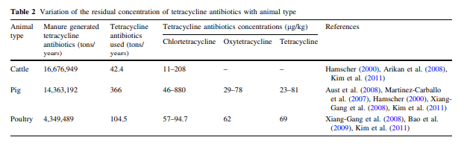

-Effect on aquatic species:

- maybe inhibit growth of microalgae

At concentrations of 10mg/L or .1 mg/L noted endocrine disruption in fishes

Several methods already: membranes, adsorption, photochemical, electrochemical, photocatalytic and photoelectrical processes

Future trends and perspectives: effect in soil? Does it increase genes? (in sludge it seems yes), pretreatment to make organisms less sensitive

Antibiotic Use in Agriulture and Its Impact on the Terrestrial Environment, Kumar et al. 2005

Unclear results.

-used to promote growth in feed animals

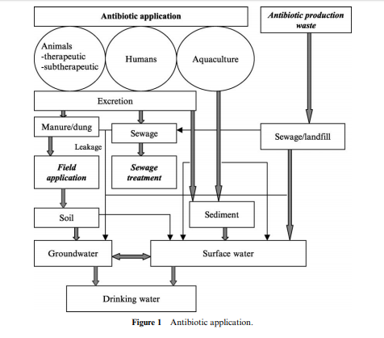

Pathways for the spread of antib resistance genes: selection in animal gut and release, transfer of genes in manure into other systems, accumulation and then consumption by humans, manure to impart resistance on the rest of the environment

No data on actual antibiotic use

Factors affecting biodegradation: temperature, soil type, soil-manure ratio (for chlorotetracycline decrease in ratio reduced recovery b/c adsorption or decomp), animal excreta pH and UV light.

Inactivated by metals, tetracycline chelare with mg2+ Ca2+ Fe3+ Zn2+ and Al3+. Effectiveness of antib decreased with decrease in soil adsibed antibs.

Degradation products: some products of OT, T,CT have similar potenct as the parent compound in soil and activated sludge

Transport in ground water: high levels in manure sometime low in water for T’s b/c high sorption coeff

In plants

“In a study on pinto beans (Phaseolus vulgaris var. Univ. of Idaho 114) grown in aerated nutrient media with chlortetracycline and oxytetracycline at 160 mg L1 , top and root dry matter were reduced by 71 to 87% and 66 to 94%, respectively (Patten et al., 1980). The results also showed that even relatively low antibiotic concentrations markedly aVected pinto bean growth and development. Patten et al. (1980) found that neither chlortetracycline nor oxytetracycline aVected the growth, development, or nutrient composition of corn grown in a sandy loam soil. However, yields of edible radish (Raphanus sativus L.) and nutrient uptake by wheat (Triticum aestivum L.) and corn grown on a clay loam soil were greater than the control for either antibiotic. This may be because antibiotics in the soil reduced pressure of pathogenic bacteria. In the same study, pinto bean yield, top and root dry matter, and nutrient uptake (Ca, Mg, K, and N) decreased in the presence of antibiotics in the sandy loam soil. There were also 52 and 67% fewer nodules on roots in the presence of chlortetracycline and oxytetracycline, respectively. However, for the same range of concentrations, there was no adverse eVect of antibiotics on bean plants in a clay loam soil. These results show that the eVects of antibiotics depend on soil characteristics and plant sensitivities”

Broad spectrum: decrease effectiveness of nitrification in soil

Presence of resistance microbes increase with application of manure high in antibs

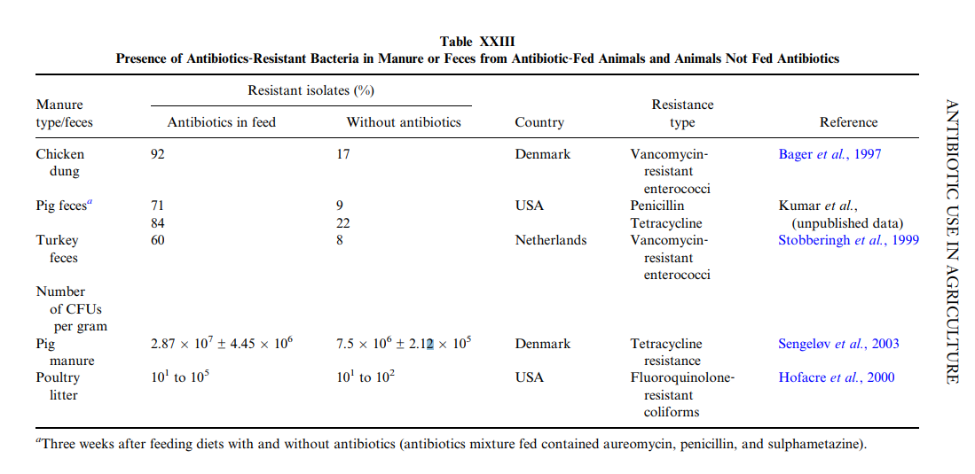

Human health concerns: resistance, widespread effects with it. Also changes efficacy of new (if similar) treatments.

Hu, Zhou,Luo. Occurrence and source analysis of typical veterinary antibiotics in manure, soil, vegetables and groundwater from organic vegetable bases, northern China. 2010

* Very temperature sensitive
* Winter values higher
* “With the application of manure containing antibiotics to organic vegetable bases, the residues of antibiotics in soil, vegetables and groundwater were widely detected. After varieties of antibiotics migrated from manure to soil, the physical and chemical properties significantly affected their occurrence. It was worthy of our attention that antibiotics performed the biological accumulation at the low concentration. Compared with antibiotics in summer, there were more antibiotic residues and higher environmental risks in winter. Antibiotic residues have undoubtedly a great pressure on the safety of ecosystems and human health in organic vegetable bases”

­­­­­­­­­­­­­­­­­­­­­­­­­­­­­­­­-______________________________  
DOI 10.1007/s12010-013-0559-6 (This one is pretty good)

Biodegradation of Tetracycline Under Various Conditions and Effects on Microbial Community Zeynep Cetecioglu & Bahar Ince & Samet Azman & Orhan Ince

Batch biodegradation under anoxis and anaerobic conditions. Three conditions: S-reducing, NO3-reducing, methanogenic. 120 days

__________________________  
Insight into metabolic and cometabolic activities of autotrophic and heterotrophic microorganisms in the biodegradation of emerging trace organic contaminants

Ngoc Han Tran, Taro Urase, Huu Hao Ngo, Jiangyong Hu, Say Leong Ong,

<https://doi.org/10.1016/j.biortech.2013.07.083>

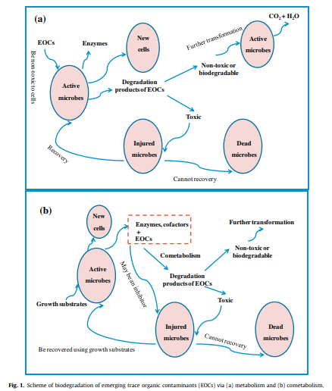

Jeong et al. 2009. Degradation of tetracycline antibiotics: mechanisms and kinetic studies for advanced oxidation/reduction processes.

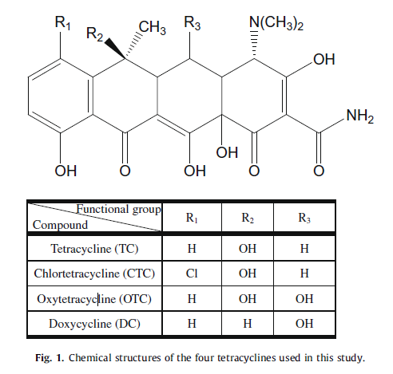

Larsson

Levels are higher in sludge and manure waste than in aquatic systems

Many antibs bind strongly to particles and likely only a fraction is bioactive

Some very persistent found at ng/L, near manufacturing discharges ug/l can be seen

Potential that microorganisms in soil (nutrient fluxes, nitrogen fixation) get disrupted, but no clear evidence yet

Given time most systems will still develop even in the presence of antibs

Selection from HGT a concern, only needs to happen once to be an issue

In environments with manufacturing discharges, [] well over min inhib [] are found therefore exposure drives resistiance selection

But a question in field settings: is the field or the manure that’s doing the selecting

----------------------------

Wen, Jia, Li. 2010. Enzymatic degradation of tetracycline and oxytetracycline by crude manganese peroxidase prepared from Phanerochaete chrysosporium

Mangannsese peroxidase: MnP, from Phanerochaete chrysosporium, a white rot fungus. Good catalyst for TC and OTC

Other methods: membrane contractor processes, activated carbon and palygorskite adsorption, UV, ozone tech are somewhat effective but nit fewasible.

Use for crude enzymes here, because cheaper, extracellulae lihnonolytic enzymes. Using just enzyme excludes some limiting factors: growth on large scale, incubation processes, and effects of polluants on mycelia

TC and OTC chosen bc wide app, high residual toxicity, high solubility in h2o, and non-biodegration

Rxn initiated with addion of h2o2 (indicated enzymatic degradation)

In four hours 72.5% TC and 84.3% OTC degraded

Optimization of system parameters: best removal at ph 2.96 (so low!) (but stayed ok at level up to 4.8)

Increase with T up to 37-40 (enzyme peak)

Generally good with more manganese to a point. (1.mM)

H2O2 at .2 mM, genrerally more enzyme was better

Wenbo Liu, Nora B. Sutton, Huub H. M. Rijnaarts & Alette A. M. Langenhoff (2016) Pharmaceutical removal from water with iron- or manganese-based technologies: A review, Critical Reviews in Environmental Science and Technology, 46:19-20, 1584-1621, DOI: 10.1080/10643389.2016.1251236

Microorganisms can produce Fe- or MN- oxides which remove pharmatceticals by chemical oxidation, bacteria can help: biologically catalyzed advanced oxidation

“. These bioMnOx are produced by oxidation of Mn(II) by bacteria such as Pseudomonas putida MnB6 (BCCM/LMG 2322) and Bacillus sp. SG-1, or fungi (Hennebel et al., 2009; Tebo et al., 2004). Enrichment of P. putida which was used to generate bioMnOx was achieved under nitrifying conditions in a down flow sponge reactor with artificial wastewater (Cao et al., 2015). As compared to synthetic MnO2, microbially produced bioMnOx has a unique structure, yielding a variety of advantages for oxidation. BioMnOx are reactive under neutral pH ~7),”

Goods and bads: non-specificity, specific treatment conditions, intermediates and byproducts

Joss, A., Zabczynski, S., G€obel, A., Hoffmann, B., L€offler, D.,McArdell, C.S., Ternes, T.A., Thomsen, A., Siegrist, H., 2006. Biological degradation of pharmaceuticals in municipal wastewater treatment: proposing a classification scheme. Water Res. 40 (8), 1686e1696.

_______________________